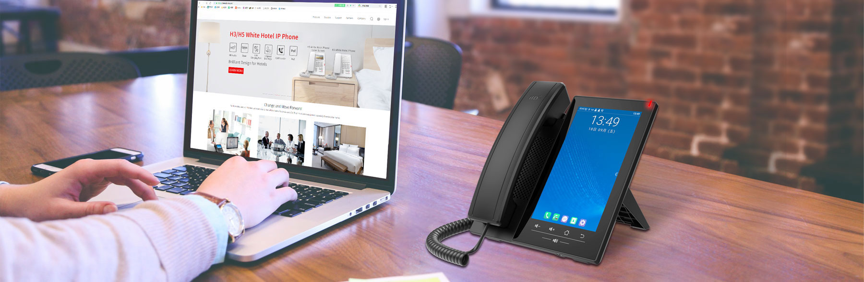

H7 Android Touch Screen IP Phone

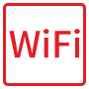










As a high-end enterprise IP phone with Android 9.0 OS, J7A provides a more intelligent and smoother touch operation experience for the users. 120 DSS keys on the 7-inch color touch screen, supported 3rd party apps, built-in Wi-Fi and Bluetooth, allows daily communication smarter and simpler. Matching an adjustable USB camera, J7A can deliver a superb audio and video for the group conference.  Highlights  20 SIP lines, 3-way conference, hotspot  Support an external designated USB camera (optional)  120 one-touch DSS keys on 7” capacity color touch screen  HD audio on speaker and handset  Built-in Bluetooth 5.0 and 2.4G/5G Wi-Fi  Video Codec H.264 support for receiving video calls.  Dual Gigabit ports, integrated PoE  Stand with 2 adjustable angles of 40 and 50 degrees  Compatible with major platforms: Asterisk, Broadsoft, 3CX, Metaswitch, Elastix, Avaya etc.  OEM Support  Software Logo  Web Logo and Model  Packaging (Label and Gift box) | 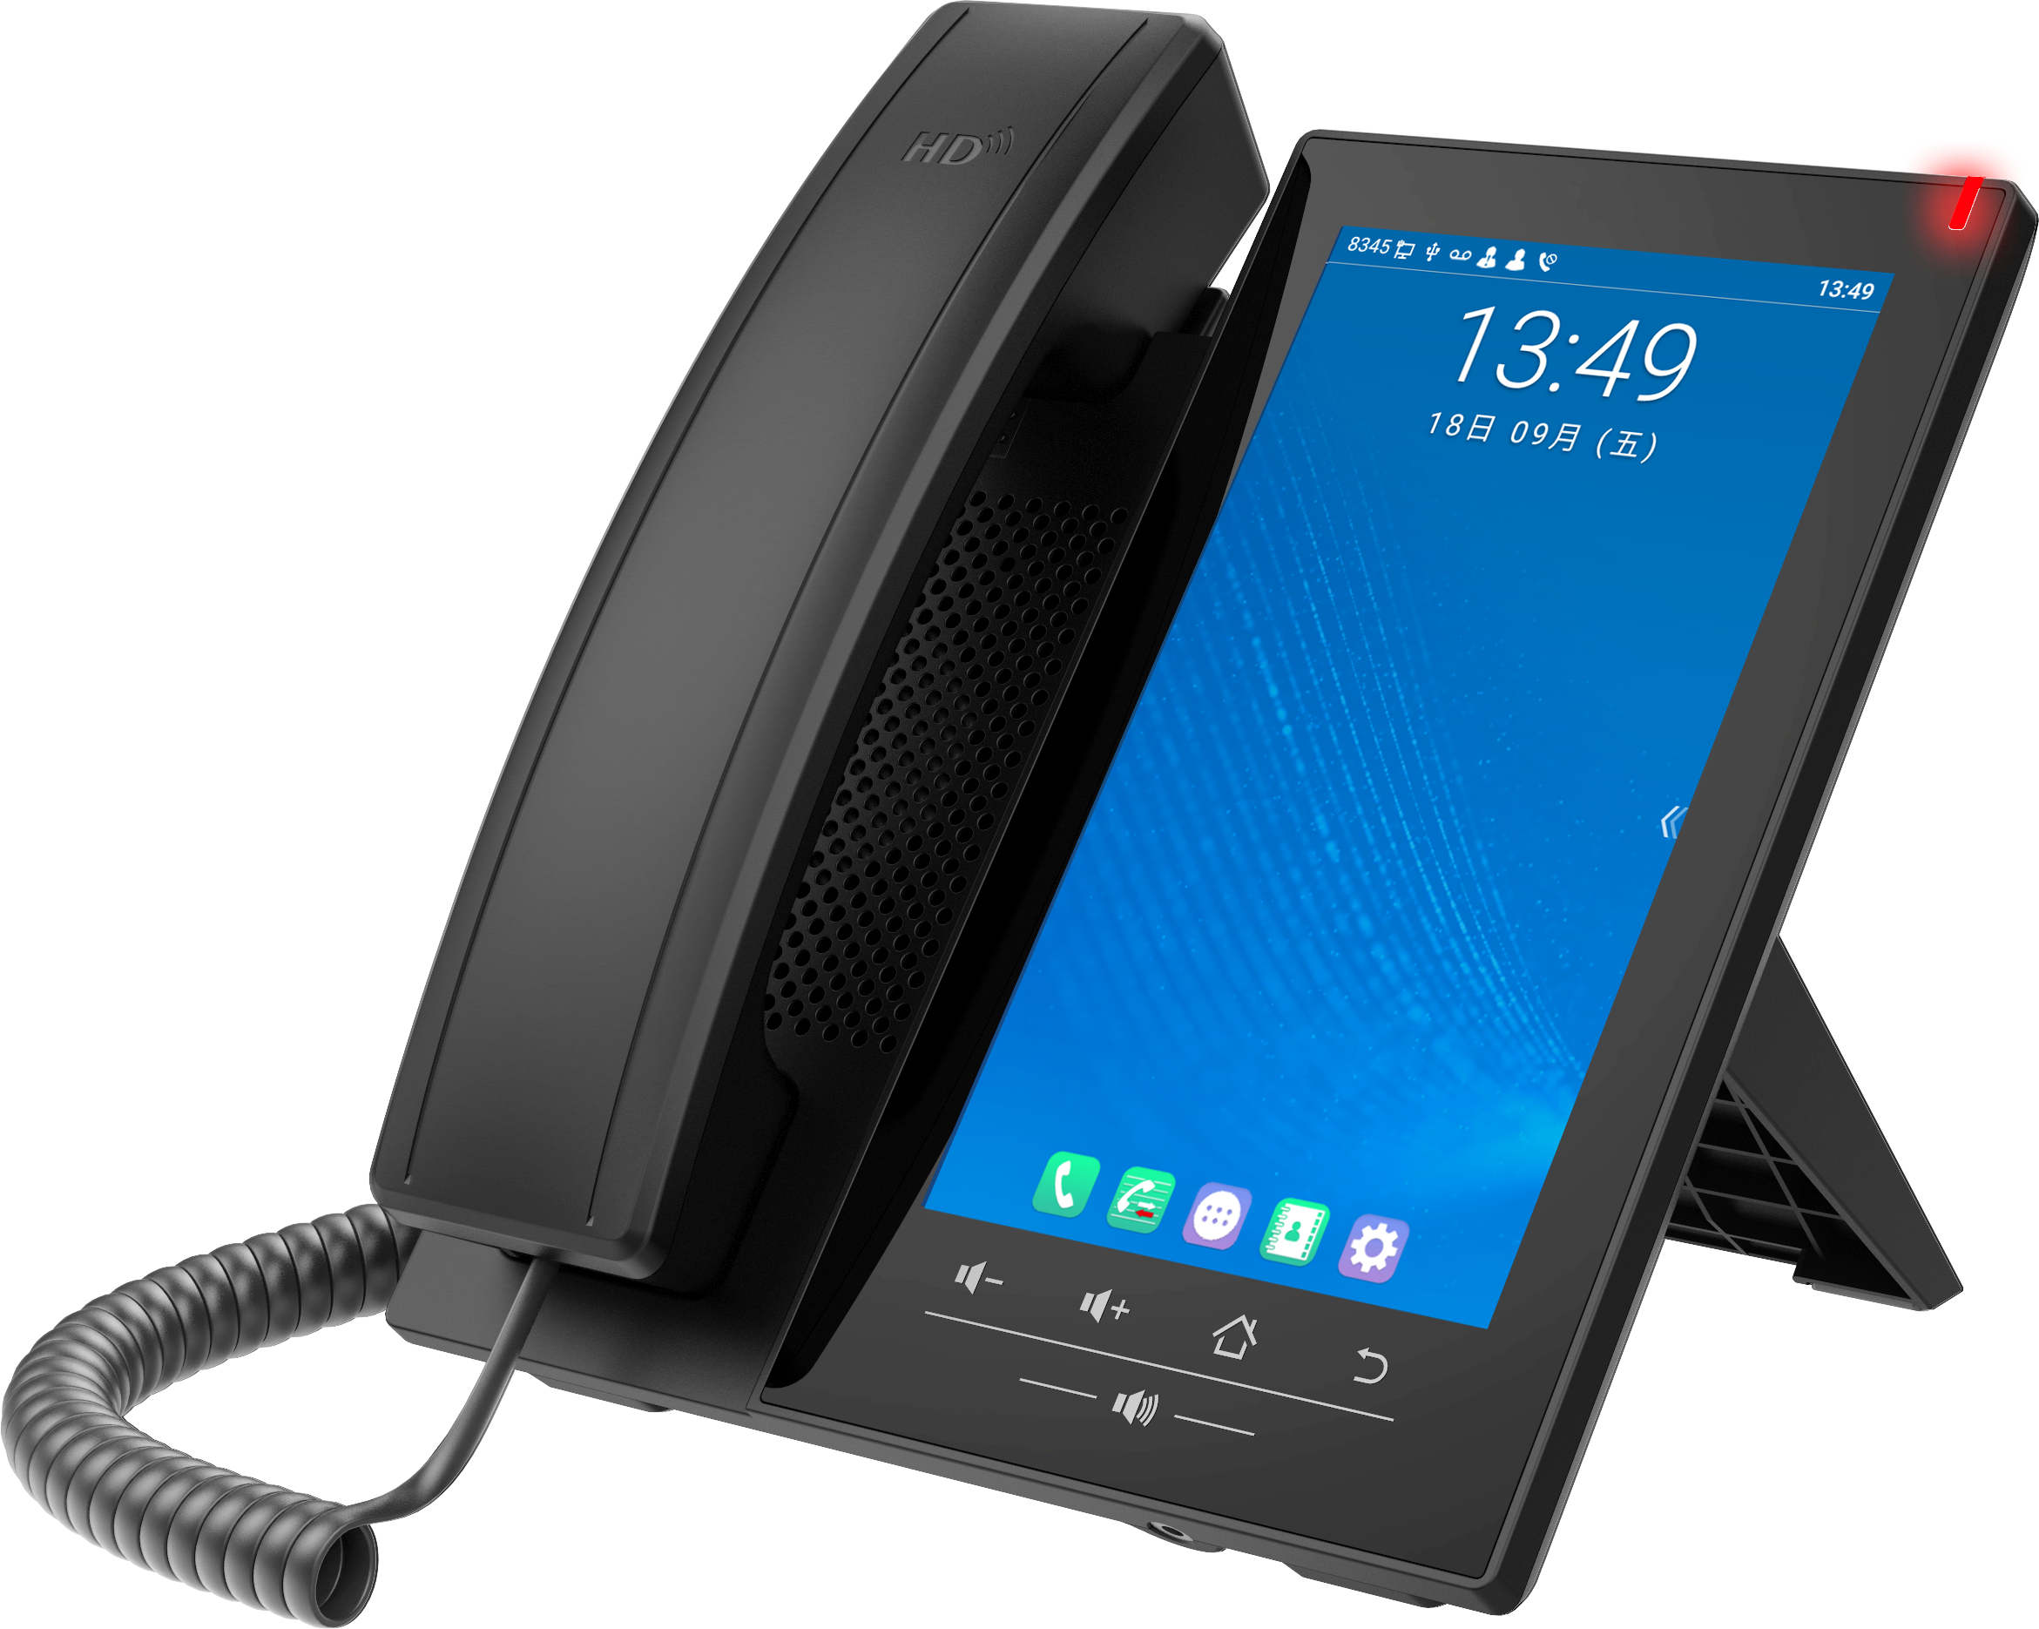

Generic
- 20 SIP Lines
- HD Voice
- Support receiving video call
- PoE Enabled
- 7-inch (1024x600) color touch screen
- Handset / Hands-free / Headset mode
- Intelligent DSS Keys(Virtual buttons)
- Optional External Power Supply

Operation System
- Android 9.0 OS with higher security and better compatibility
- Built-in Applications:
Files, Calendar, Gallery, Browser, Email, Calculator, Notepad, Sound Recorder, Clock, Video, Music
- Support 3rd Party Applications
- Secondary Development of API

Phone Features
- Local Phonebook (2000 entries)
- Remote Phonebook (XML/LDAP, 2000 entries)
- Intelligent Search for Contacts and Call Log
- Call logs (In/out/missed, 1000 entries)

- Black/White List Call Filter
- Screen saver
- Voice Message Waiting Indication (VMWI)
- Programmable DSS/Soft keys
- Network Time Synchronization
- Built-in Bluetooth 5.0: Support Bluetooth headset/ Bluetooth of
Mobile Device
- Built-in Wi-Fi
- 2.4GHz, 802.11 b/g/n
- 5GHz, 802.11 a/n/ac
- Support Recording
- Action URL / Active URI
- UaCSTA
- Audio/Video Recording

- SIP Hotspot
- Group Broadcasting
- Action Plan
- Group listening

Call Features
- Call out / Answer / Reject
- Mute / Unmute (Microphone)
- Call Hold / Resume

- Call Waiting
- Intercom
- Caller ID Display
- Speed Dial
- Anonymous Call (Hide Caller ID)
- Call Forwarding (Always/Busy/No Answer)
- Call Transfer (Attended/Unattended)
- Call Parking/Pick-up (Depending on server)
- Redial
- Do-Not-Disturb
- Auto-Answering
- Voice Message (On server)
- 3-way Audio Conference
- Hot Line
- Hot desking
- BLF

Video
- Video decoding: H.264 /H.265(Optional)
- Video call resolution: CIF/VGA/4CIF/720P/1080P
- Image format: JPEG/PNG/BMP
- Video format: MP4
- Bandwidth selection: 64kbps~4Mbps
- Frame rate selection: 5~30fps
- Video from remote site can be displayed in full screen
- 3-way Video Call with External Camera
- Optional designated USB Camera
- 2 Mega Pixel
- Plug and Play
- Flexible Placement and Angle Adjustment
- Video Preview

Audio
- HD Voice Microphone/Speaker (Handset/Hands-free, 0 ~ 7KHz Frequency Response)
- HAC handset
- Wideband ADC/DAC 16KHz Sampling
- Narrowband Codec: G.711a/u, G.729AB, iLBC
- Wideband Codec: G.722, Opus
- Full-duplex Acoustic Echo Canceller (AEC)
- Noise Reduction (NR)
- Packet Loss Concealment (PLC)
- Dynamic Adaptive Jitter Buffer
- DTMF: In-band, Out-of-Band – DTMF-Relay(RFC2833) / SIP INFO

Network
- Physical: 10/100/1000 Mbps Ethernet, dual bridged port for PC bypass
- IP Mode:IPv4
- IP Configuration: Static / DHCP
- Network Access Control: 802.1x
- VPN: OpenVPN (Requires third-party app support)
- VLAN
- LLDP
- CDP

- QoS

Protocols
- SIP2.0 over UDP/TCP/TLS
- RTP/RTCP/SRTP
- STUN
- DHCP
- CDP
- LLDP
- PPPoE
- 802.1x
- OpenVPN (Requires third-party app support)
- SNTP
- FTP/TFTP
- HTTP/HTTPS
- TR-069

Deployment & Management
- Auto-Provisioning via FTP/TFTP/HTTP/HTTPS/DHCP OPT66/SIP PNP/TR-069
- Web Management Portal
- Supports the third party communication APP
- Supports Web, Telnet
- Supports encrypted configuration files download with AES
- Supports Web upgrade
- Supports factory reset data

Physical Specifications
- Color: Black
- LCD x1: 7- inch (1024x600) color touch screen
- Touch keys x5: Volume -/Volume +/Home/Return/Hands-free
- HD Handset (RJ9) x1
- Standard RJ9 Handset Wire x1
- 1.5M CAT5 Ethernet Cable x1
- Back Rack x1
- RJ9 Port x2: Handset x1, Headset x1
- RJ45 Port x2: Network x1, PC x1 (Bridged to Network)
- USB2.0 Port x1: Standard A, Connect with Flash Driver
- Safety keyhole x1
- Power: 5V/2A or PoE
- Power Consumption (PoE): 2.39W ~ 8.77W
- Power Consumption (Adapter): 1.64W ~ 6.9W
- Working Temperature: 0~45℃
- Working Humidity: 10~95%
- Installation:
- Desktop stand
- Wall-mounted (need an additional wall hanging parts)
- Device Dimensions
- Desktop stand (angles 1: 40 degree): 181 x 175.75 x 184.4 mm
- Desktop stand (angles 2: 50 degree): 181 x 175.85 x 185.1 mm
- Wall-mounted: 181 x 115.43 x 208.75 mm
- Gift Box Dimensions: 283 x 210 x 82mm
- Outer CTN Dimensions: 440 x 435 x 304 mm (10 PCS)

The above specifications may be updated in the future without prior notice. All hardware/software/physical features should be based on the final shipped products.

Compatibility List:

